Faults
This chapter describes the causes of faults and how to correct them.

Safety instructions
DANGER!
Electrical current
Danger from electrical current
This could lead to severe or even fatal injury.
- Work on electrical or operating equipment may only be performed by an electrical engineer.
- Observe the electrical engineering rules when car‐ rying out work on electrical or operating equipment.
- Disconnect and secure the machine before working on the electrical or operating equipment.
DANGER!
Restarting after a machine malfunction
Danger due to unchecked restarting after a machine malfunction.
This could result in death or serious injury.
- Only start the machine if the cause of the malfunc‐ tion has been clarified and eliminated.
- Before restarting, ensure that nobody is in the danger area.
DANGER!
Suspended loads
Falling loads may lead to serious or fatal injury.
- Secure suspended loads.
- Do not work under suspended loads.
- Never swing loads above personnel.

DANGER!
Falling retaining pressure with suspended load
During an emergency stop, part of the pneumatic system continues to be supplied with pressure. This part of the pneumatic system is monitored by sensors and holds suspended loads in position. If the sensors report a pressure drop, then an audible warning signal sounds.
Falling loads may lead to serious or fatal injury.
- Ensure that the noise level in the vicinity of the machine allows audible warning signals to be heard.
- Do not stand underneath the suspended load when correcting faults in the vicinity of the suspended load.
- Immediately leave the area of the machine when the audible warning signal sounds.
WARNING!
Residual energy when the machine is switched off If there are faults, components do not always return
to their final position. As a result, components contain residual energy in the form of potential energy.
Residual energy can be released during trouble‐ shooting.
This could result in death or serious injury.
– Secure and de-energize the machine before car‐ rying out any work on the machine.
CAUTION!
Impermissible operating pressure
Lacerations and bruises caused by bursting machine parts conducting compressed air.
This could cause slight or minor injury.
– Do not exceed the maximum operating pressure.
See specifications on the maintenance unit for operating pressure specifications.


NOTICE!
Operating in manual functions
Components are not blocked in relation to one another by confirmation prompts when operating in a manual function.
This leads to a risk of collisions between components.
This may result in damage to the machine or the sur‐ rounding area.
– When operating the components in a manual func‐ tion, care must be taken to ensure that the paths to be traveled are free and that components will not collide with one another.

  - Detecting faults
If the machine control system identifies a fault condition, it generates a fault code based on the sensor messages involved and stops the controlled area.
The signaling unit indicates the fault condition by means of an acoustic signal and displays a visible signal.
To find out which area in the system is stopped as a result of a machine emergency stop, refer to the [Emergency stop layout] docu‐ ment; see chapter “General”, section “Scope of technical documen‐ tation”.

  - Rectifying faults
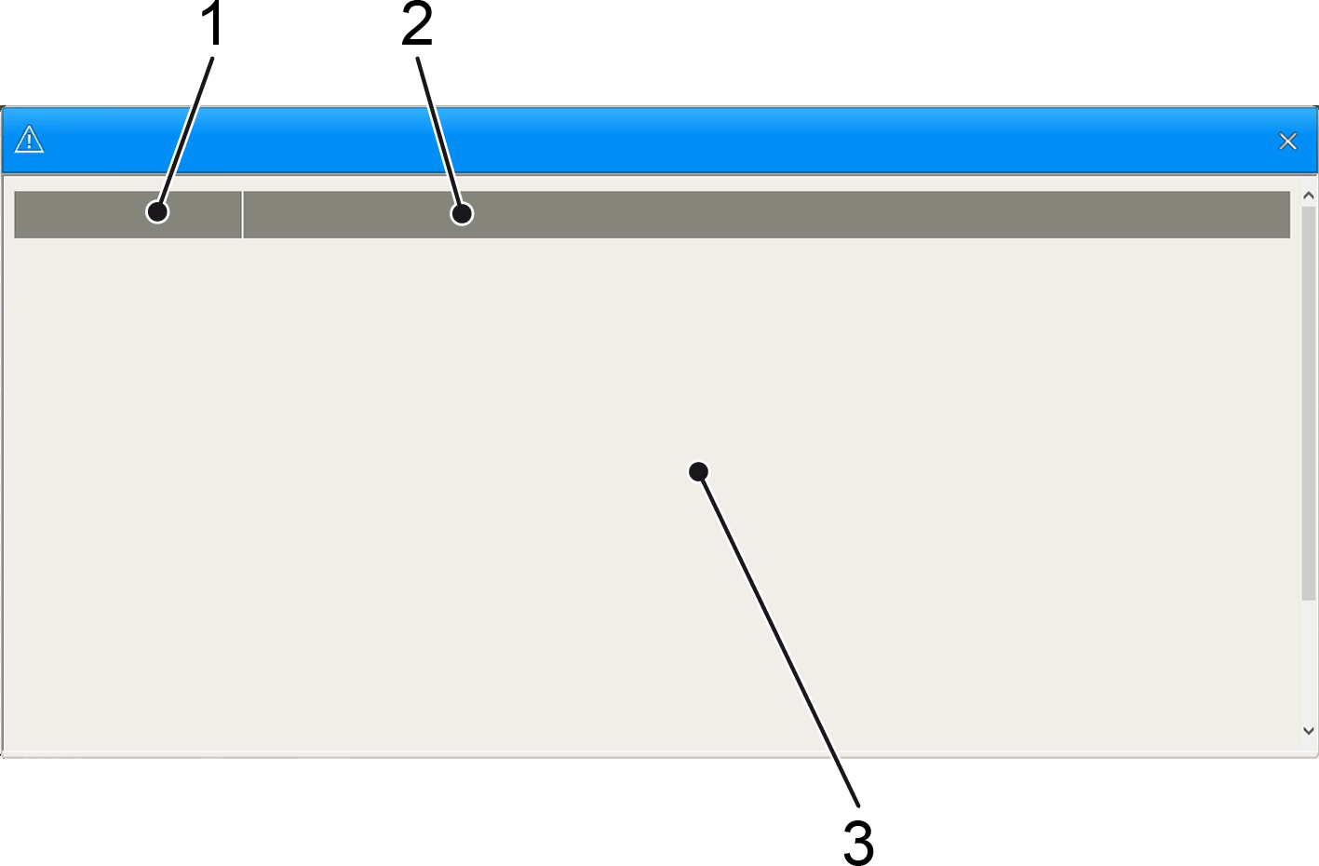

Figure 98: View of a fault rectification on the operator console
- Fault number
- Fault text
- Troubleshooting
Troubleshooting instructions have been stored for every fault mes‐ sage. Tapping the fault message on the dashboard opens a dialog with troubleshooting for the triggering fault message.
Troubleshooting comprises a fault number, the fault text and infor‐ mation on how to resolve the fault. The fault text consists of the assembly, a short description and an optional designation of the reporting sensor.

Multiple existing fault messages
The cause of the fault and the switch to emergency stop mode can lead to a variety of subsequent faults.
Tapping the display field always opens the first fault message and consequently the root cause of the mes‐ sage.
Personnel:  Operating personnel
  - Maintenance personnel

- Tap the fault message on the dashboard.
  - The “Troubleshooting” view for the triggering fault message opens.
- Carry out the instructions provided in the “Troubleshooting” view depending on your qualification.

Teleservice operating mode
Personnel:  Maintenance personnel
Switch the [Operating mode] key switch to the [Teleservice]
position.
- Teleservice operating mode is active. Remote diagnostics and remote control for troubleshooting and fault rectification can be carried out by KHS personnel.

Troubleshooting on safety equipment
This chapter contains detailed descriptions for fault messages of elec‐ trically monitored safety equipment.

Securing lift device for load not secured or load not released Source of fault
The fault messages “Securing lift device for load not released” and “Securing lift device for load not secured” are fall arrester fault mes‐ sages. Every fall arrester is monitored by a sensor.
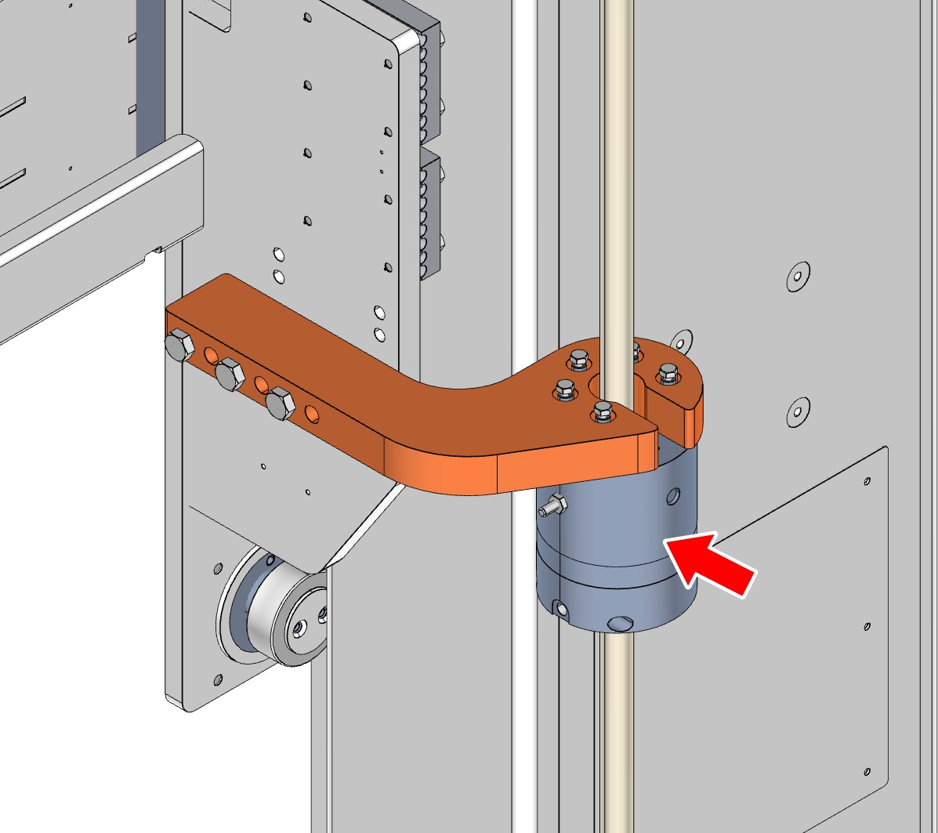

Figure 99: Position of the fall arrester on the frame and lifting frame of the machine
During preparation of the machine for operation, the sensor checks whether the fall arrester is open when compressed air is present. If this signal fails to appear, the machine control system generates the fault message “Securing lift device for load not released” .

If the machine switches to the Off operating status as a result of a fault message, the sensor checks whether the fault arrester closes. If this signal fails to appear, the machine control system generates the fault message “Securing lift device for load not secured” .

Troubleshooting
Troubleshooting for “Securing lift device for load not released” and “Securing lift device for load not secured” entails an increased risk of personal injury.
If a fall guard has not opened, and the pneumatics and the sensor have been checked, the clamping element must be replaced.
If a fall guard has not closed, and the sensor has been checked, the clamping element must be replaced.
In both cases, the lifting frame must be treated as an unsecured suspended load and must be secured against a sudden drop using suitable support elements before working on the clamping elements.

Monitoring of compressed air Source of fault
The pneumatic system is equipped with a pressure monitor. If the pneumatic pressure drops below the preset minimum operating pres‐ sure, the pressure monitor triggers an emergency stop and the depressurization system decreases the pressure in the fall guards and the connected pneumatic system.
Messages containing the text “Monitoring compressed air” are fault messages of the pressure monitor on the maintenance unit.

Troubleshooting
If the depressurization system triggers an emergency stop despite an adequate compressed air supply at the local connection, the preset pressure at the sensor must be checked or the cabling or sensor must be replaced. Bypassing the sensor signal constitutes improper use of the machine.

Sensor repeatedly switches to emergency stop mode when the main valve is opened
The pressure monitor must report the intended pres‐ sure within a specified period of time. If the pneumatic pressure is not reached within this period of time,
the pressure monitor again switches the machine into emergency stop mode.
A leak in the pneumatic system or a faulty sensor is not necessarily the cause.
Check the following other causes:
- The main valve or a manual shut-off valve is not completely open.
- The local supply does not provide sufficient com‐ pressed air.
- Restricted flow because of kinks in the pneumatic hoses, for example.
- When repairing the local pneumatic supply, the compressed air system was connected with another machine for parallel extraction. Supplying multiple machines with compressed air simultane‐ ously can significantly reduce the local pressure supply as a result of the unexpected high level of extraction of compressed air.

Monitoring of compressed air safety valve Source of fault
The pneumatic system is equipped with a depressurization system. When an emergency stop is triggered the depressurization system opens and decreases the pressure in the fall guards and the con‐ nected pneumatic system.
Messages containing the text “Monitoring of compressed air safety valve” are fault messages of the safety valves on the fall guards. If a message such as this is occurs, the lifting frame must be treated as an unsecured suspended load.

Troubleshooting
If the safety valves send a fault message the cabling and safety
valve must be checked and replaced where necessary. Bypassing the sensor signal constitutes improper use of the machine.

Emergency stop on safety door Source of fault
A safety door consists of a frame, the movable door mounted in this frame, a closure mechanism and a sensor on the frame. The sensor monitors whether the safety door is closed or not. If the sensor does not send a signal, the machine control system assumes that the door is being opened and triggers an emergency stop to protect personnel.

Troubleshooting
Irrespective of the cause of the fault message, the sequence of trou‐ bleshooting steps must be adhered to so as to minimize the risk of personal injury.
Personnel:  Maintenance personnel
      - Operating personnel
- Check the cause of the fault message at the safety door and resolve the fault.
- Ensure that there is nobody in the secured area.
- Close the safety door.
- Acknowledge the fault on the actuation housing [Safety door].
- Start up the machine again.

Troubleshooting with increased risk
This chapter describes troubleshooting that involves an increased risk of personal injury.

Eliminating jams Source of fault
Every movement of an assembly is monitored by sensors. If an assembly is moved, these sensors must signal the reaching of the starting position or end position within a specified period of time.
If these signals are not present within the specified period of time the machine switches to an emergency stop mode and generates fault messages such as “The unit is not open” , “The unit is closed” , “The unit has not reached the starting position or end position” or “Safety lift” .
If a jammed object is the cause of the fault there is an increased risk potential during troubleshooting.

Troubleshooting
Jammed assemblies are not secured against sudden restarting when in emergency stop mode.
Clearing jams is the most frequent cause of personal injury at the machine.
DANGER!
Jammed components
When clearing a jam, sudden execution of the move‐ ment inhibited by the jam must be expected.
This could lead to severe or even fatal injury.
- Switch off the machine and secure it against restarting.
- Do not place limbs in the movement area of jammed assemblies.
- Do not touch jammed objects directly with body parts. Use tools such as a broomstick or similarly long iron rods.
- Loosen jammed objects with thrusting movements.
- Always hold the rod loosely and perform move‐ ments away from your body.
- Position the tool so that a sudden movement of the assembly does not transfer force from the rod to your body.
- Do not stand under suspended loads.
- Do not step onto conveyor segments if they do not have protection shields between the chains or
rollers. Where necessary, use a stepping area that has been tested for breakage and shifting.
- Do not step onto movable machine parts.

Jams on the following assemblies are explicitly mentioned due to known risks:
      - The shaft area of a depalletizer
      - Flap for further transport of unloaded pallets on a depalletizer
      - Gripper heads with pneumatics that are still under pressure from an emergency stop

Removing processing material residues Source of fault
Troubleshooting frequently involves the removal of processing mate‐ rial residues. Processing material residues can block sensor signals or trigger these outside of their specified time periods. In both cases the machine identifies a fault condition based on an unexpected lack or presence of signals, stops the controlled area and issues a fault message.

Troubleshooting
DANGER!
Removing processing material residues
In terms of risk of personal injury, there is no
clear dividing line between removing processing mate‐ rial residues and clearing jams. When removing pro‐ cessing material residues, a sudden execution of the movement inhibited by the jam must be expected.
This could lead to severe or even fatal injury.
- Switch off the machine and secure it against restarting.
- Check whether processing material residues are jammed using a broom.
- If the processing material residues are not jammed, remove these residues using a broom.
- If it is not possible to remove the processing mate‐ rial residues with a broom, wear cut-resistant and puncture-proof gloves for manual removal of the residues.
- Do not lean on movable machine parts when bending down.
- Check work areas with blind spots for protruding splinters before manually reaching into them.

    - Pressurized parts Source of fault
If a fault condition is identified, the controlled area stops and the depressurization system is opened.
Depending on the current process step at the time of the fault condi‐ tion, pneumatically driven units may hold material for processing as a suspended load.
To prevent suspended loads from falling, the depressurization system does not depressurize these holding parts on the pneumatic system.

Troubleshooting
DANGER!
Falling retaining pressure with suspended load
During an emergency stop, part of the pneumatic system continues to be supplied with pressure. This part of the pneumatic system is monitored by sensors and holds suspended loads in position. If the sensors report a pressure drop, then an audible warning signal sounds.
Falling loads may lead to serious or fatal injury.
- Ensure that the noise level in the vicinity of the machine allows audible warning signals to be heard.
- Do not stand underneath the suspended load when correcting faults in the vicinity of the suspended load.
- Immediately leave the area of the machine when the audible warning signal sounds.
If the cause of the fault is on the gripper head itself and this head is holding material for processing, the processing material must be
secured against falling or must be removed before rectifying the fault.

This page is left blank for editorial reasons.

